1. Introduction

1.1 The Evolution of Wireless Ad-hoc Networking
The paradigm of wireless communication has undergone a seismic shift over the last two decades, moving from centralized, infrastructure-heavy models to decentralized, autonomous networking environments. At the forefront of this evolution is the concept of the Mobile Ad-hoc Network (MANET), a self-configuring, infra-structureless network of mobile devices connected without wires. The defining characteristic of a MANET is its inherent dynamism; each node in the network is not merely an endpoint for data consumption or production but also functions as a router, forwarding packets for its peers to ensure connectivity across the entire mesh. This decentralized nature allows for rapid deployment in scenarios where traditional infrastructure is non-existent or has been destroyed, such as in disaster recovery zones, tactical military operations, and temporary sensor deployments.
However, the versatility of MANETs comes at a significant cost: the complexity of resource management. Unlike wired networks where power and bandwidth are relatively stable, MANETs are constrained by the finite battery life of mobile nodes and the fluctuating quality of wireless links. As the demand for pervasive connectivity grows, the research community has increasingly looked toward a specialized subset of ad-hoc networking: the Wireless Sensor Network (WSN).
**Figure 1: Vanguard-WSN Architecture** (referencing `figure1_architecture.png`) illustrates the structural transition from a simple peer-to-peer ad-hoc model to a high-performance, multi-hop hierarchical architecture. While a standard MANET might rely on simple routing protocols to establish end-to-end paths, Vanguard-WSN introduces a utility-driven approach that optimizes the role of each node based on the overall health of the system. This architecture ensures that the decentralized, multi-hop nature of the network is not a liability but a strength, allowing for sophisticated load balancing that star or single-hop topologies cannot achieve.
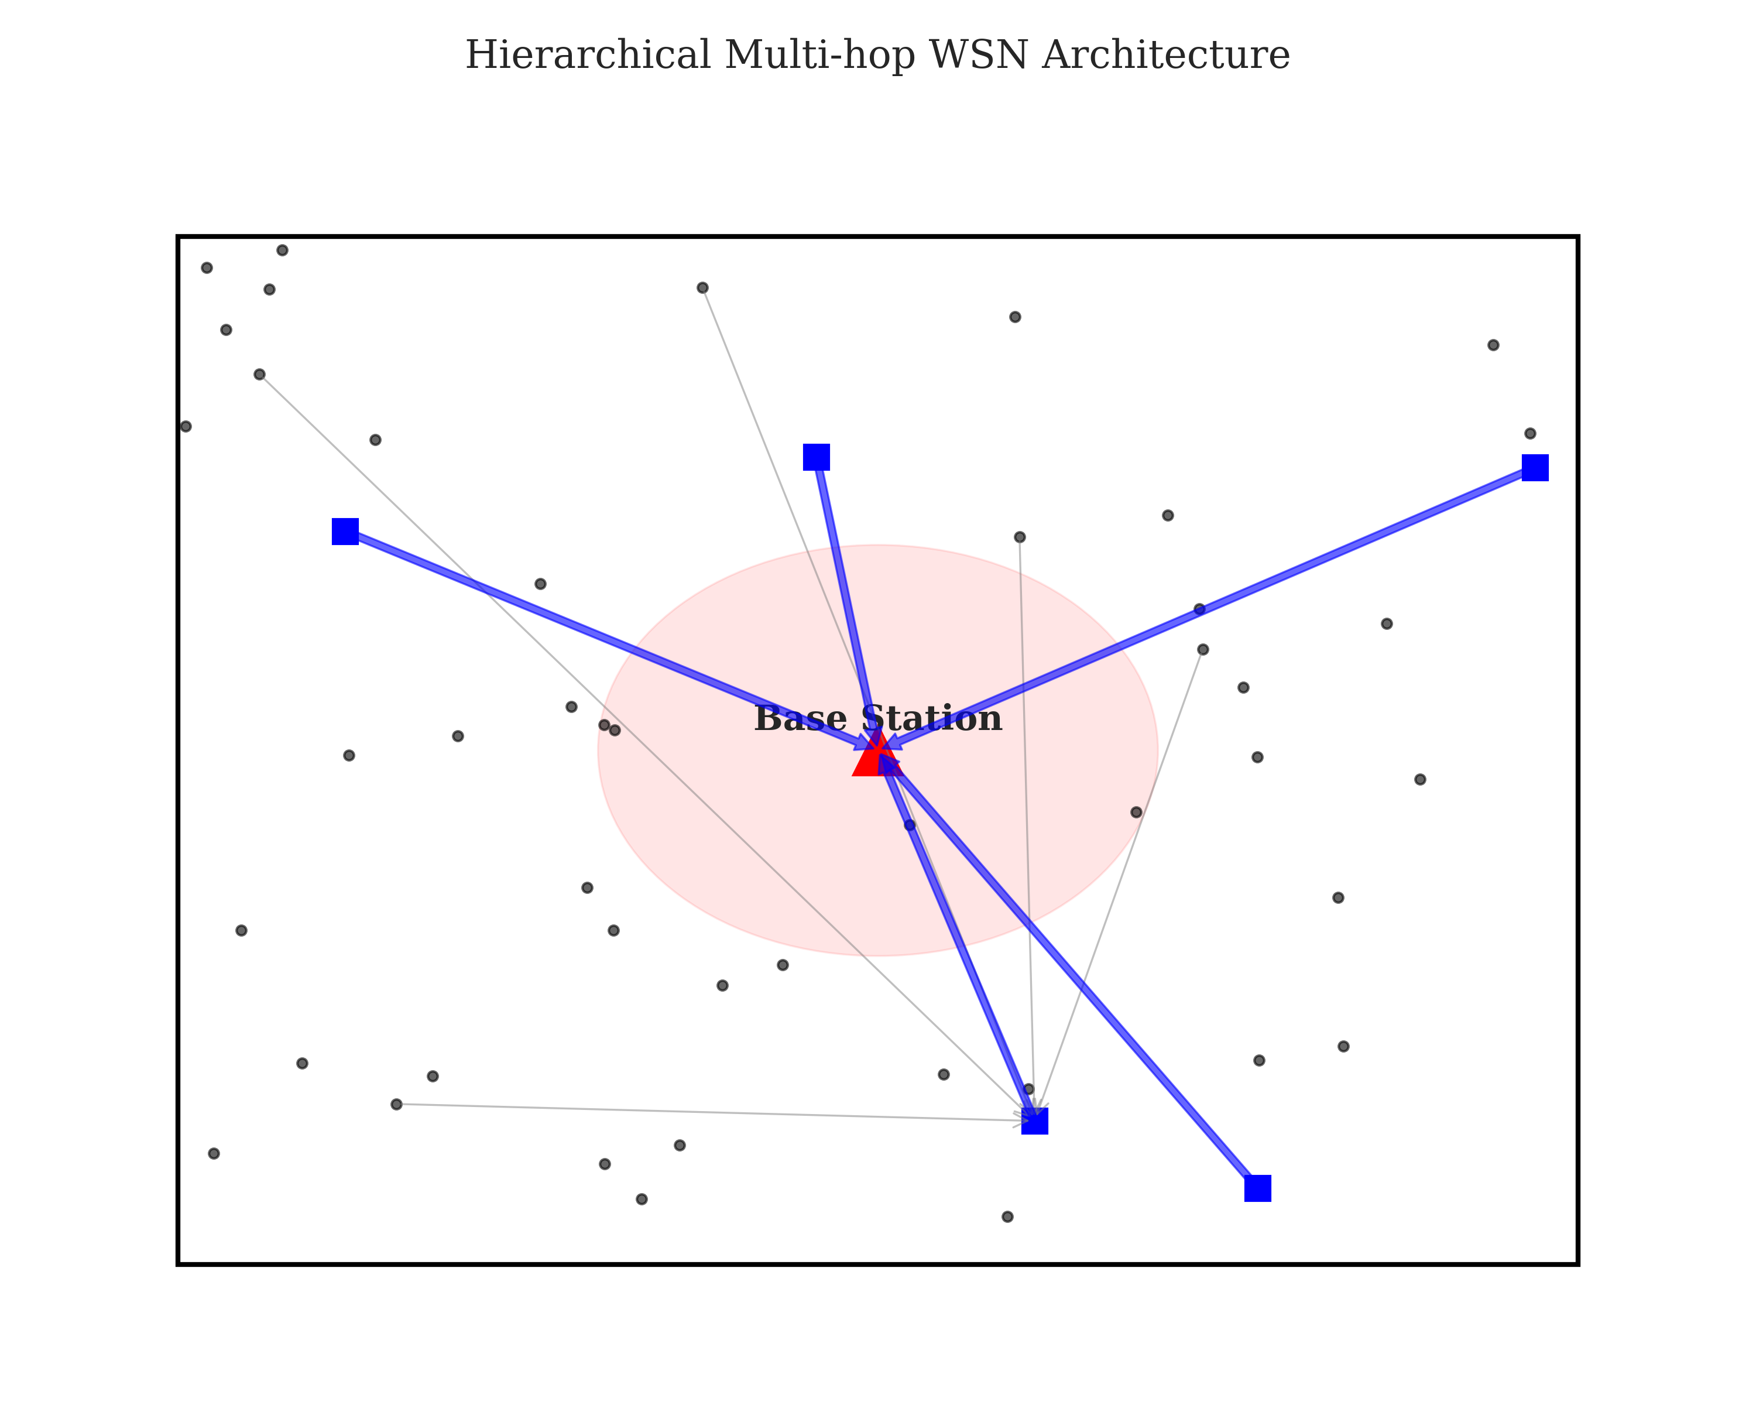

1.2 Transition to Wireless Sensor Networks (WSNs)
Wireless Sensor Networks (WSNs) can be viewed as the industrial evolution of MANET principles. While MANET nodes are typically associated with human-carried devices (smartphones, laptops, radio sets), WSN nodes are often hundreds or thousands of tiny, low-power integrated devices embedded within the environment. These nodes—equipped with sensing, data processing, and communicating components—are deployed to monitor physical or environmental conditions such as temperature, sound, pressure, or motion.
The deployment of these nodes is frequently randomized, especially in large-scale agricultural or environmental monitoring projects where manual placement is infeasible. **Figure 2: Initial Network Deployment** (referencing `figure2_deployment.png`) visualizes a typical 100x100m field where nodes are scattered in a stochastic fashion. This randomness, while easing the deployment phase, creates immediate challenges for network organization. Without a predefined structure, the nodes must self-organize into a functional topology that can relay data back to a central sink, or Base Station (BS), while navigating the physical barriers and interference localized within the field.
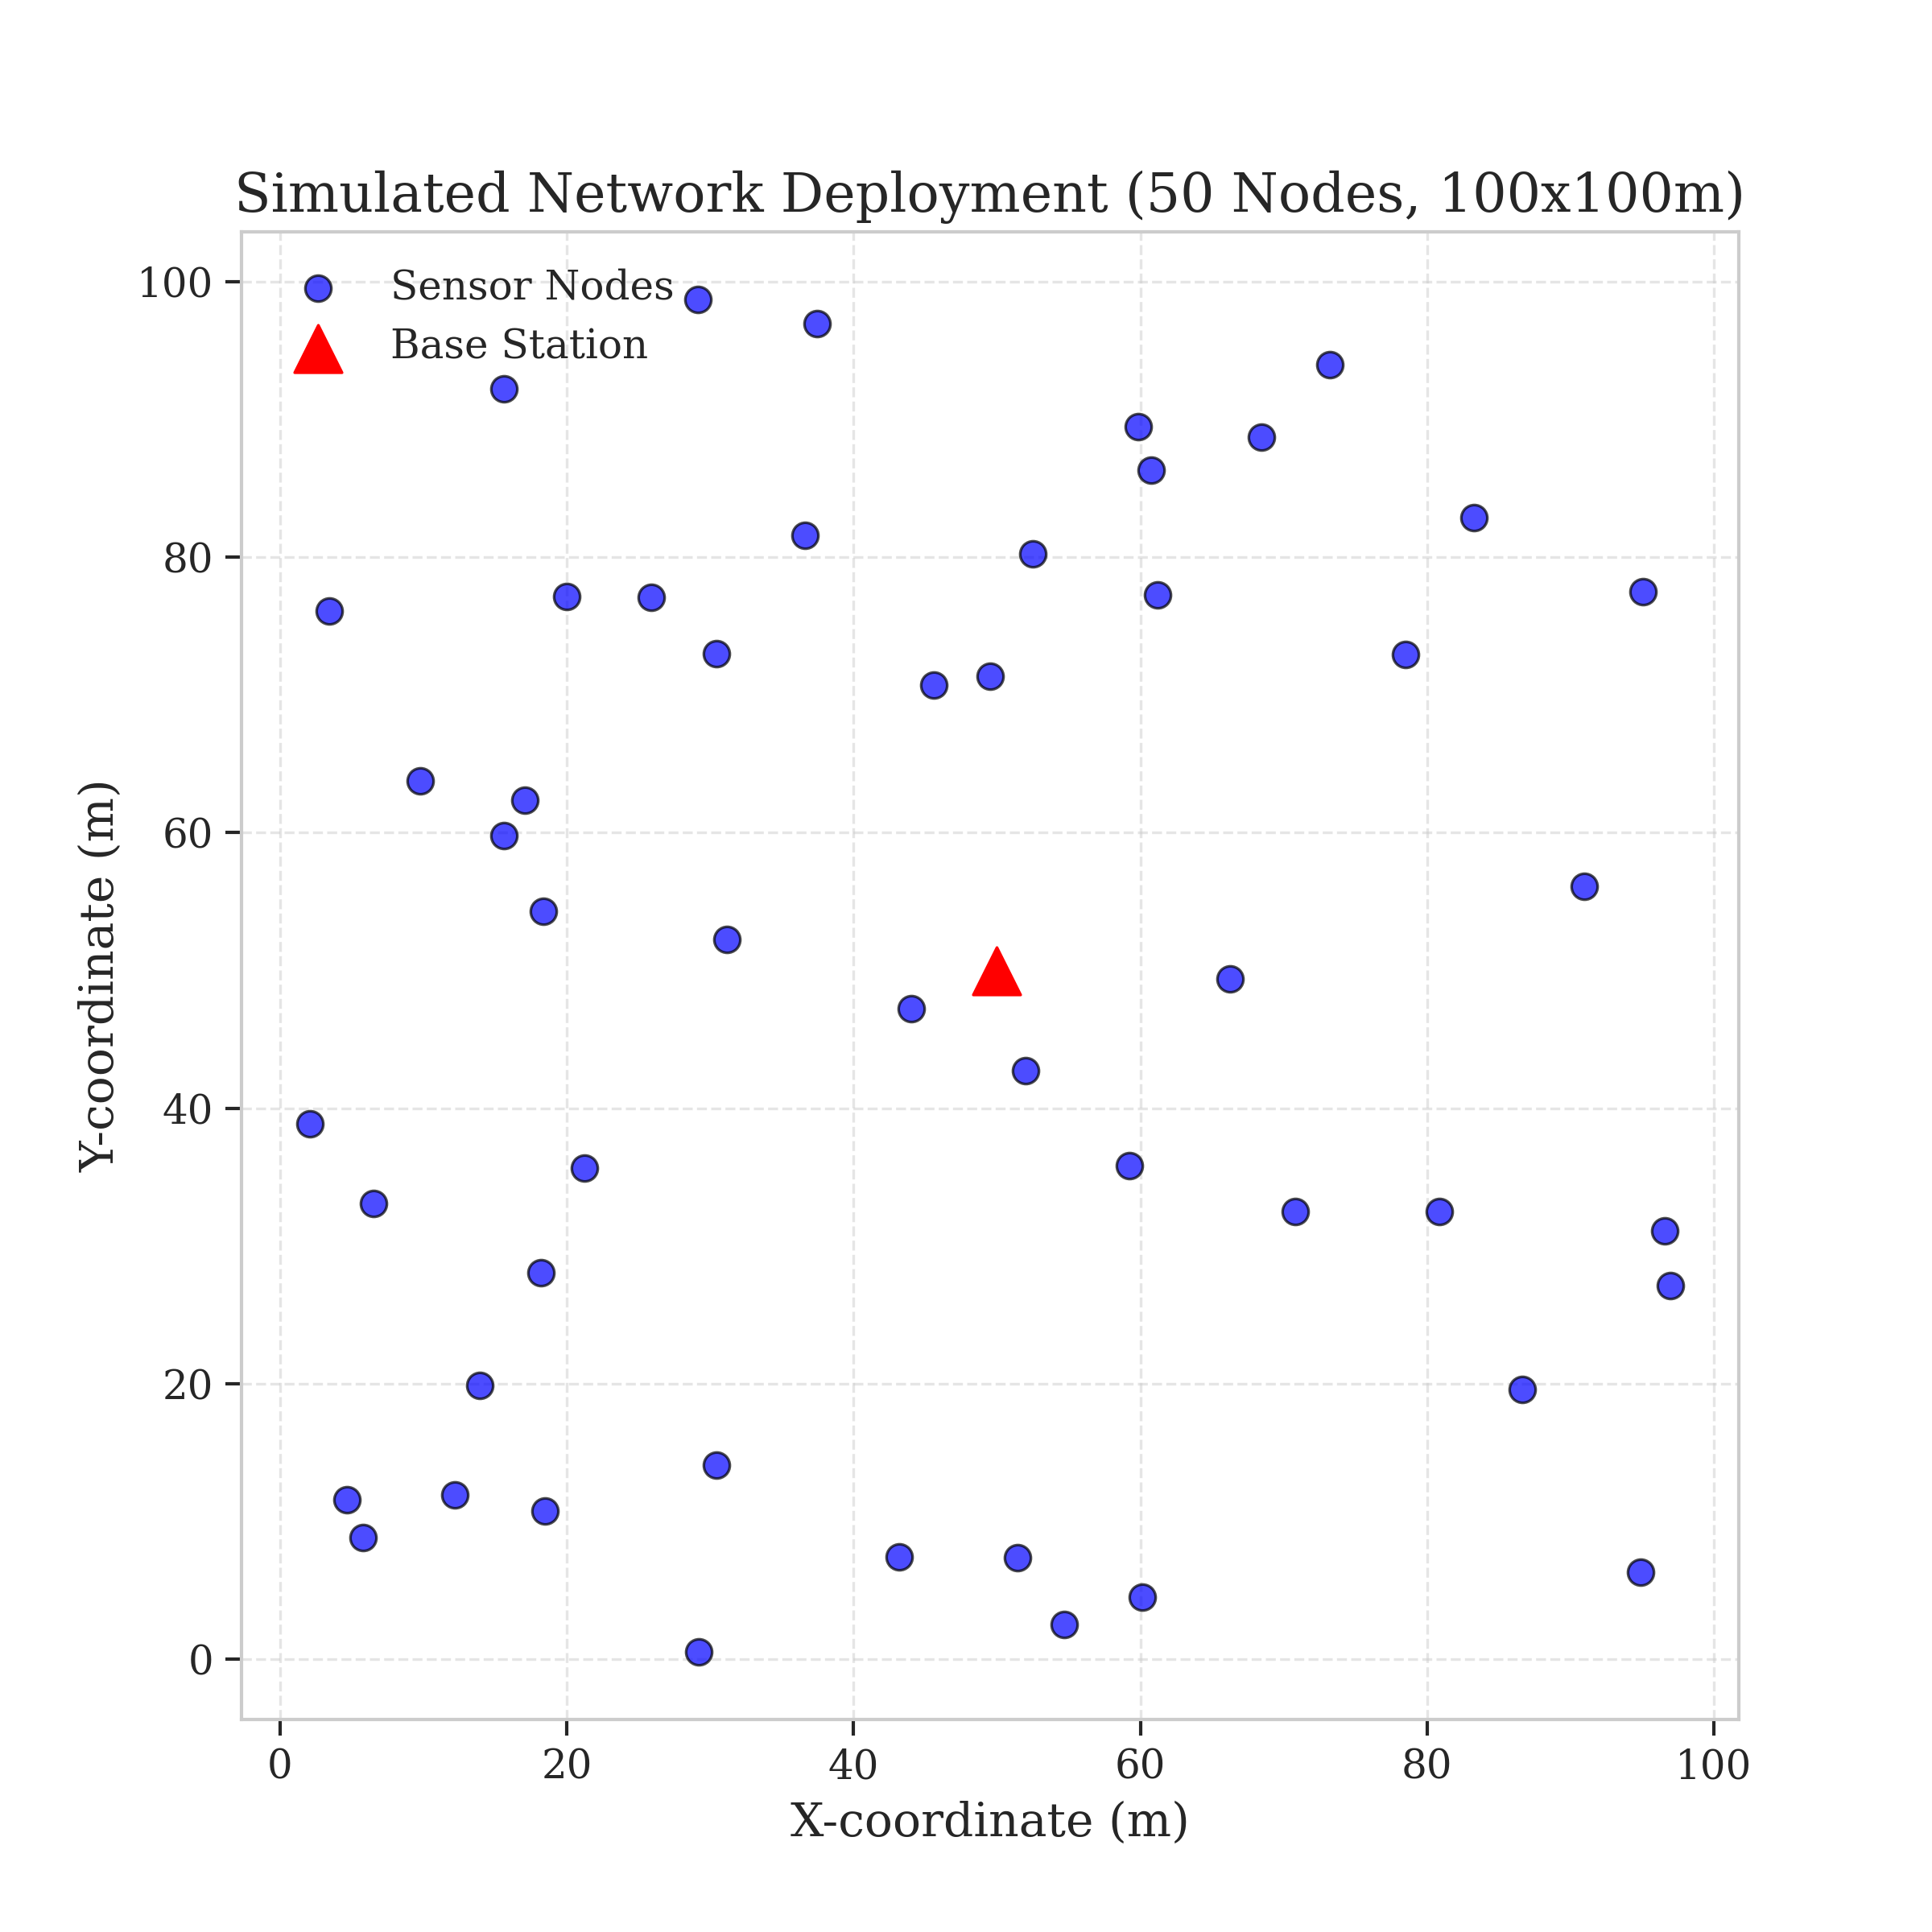
In a WSN, the primary objective shift from MANETs is the transition from "Connectivity at all costs" to "Longevity through efficiency." Because sensor nodes are often deployed in inaccessible locations where battery replacement is impossible, the "lifetime" of the network—defined as the time until the first or last node dies—becomes the critical metric for success.

1.3 The Energy Hole Problem: The Achilles' Heel of Multi-hop WSNs
Despite the benefits of the multi-hop architecture shown in Figure 1, a fundamental structural flaw plagues traditional WSN routing: the Energy Hole Problem, also known as the "Funneling Effect." In any multi-hop network where data flows toward a stationary Base Station, the nodes located in the immediate vicinity of the sink carry a vastly disproportionate traffic burden compared to those at the periphery.
Consider a node located 90 meters away from the BS in the deployment shown in Figure 2. This peripheral node only needs to transmit its own sensed data periodically. However, a node located 10 meters away from the BS must not only transmit its own data but also act as the final relay for all packets originating from the hundreds of nodes further out in the field. This geometric reality creates a "hotspot" near the sink. As these near-sink nodes exhaust their energy prematurely, they leave a void—an energy hole—through which no data can pass. Once these relay nodes die, the rest of the network, despite still possessing significant residual energy, is effectively cut off from the Base Station, rendering the entire deployment useless.
Existing literature has attempted to solve this through various clustering protocols. Protocols like LEACH (Low-Energy Adaptive Clustering Hierarchy) use probabilistic rotation to change Cluster Heads (CHs) frequently, hoping that the burden of relaying will be shared. However, LEACH and its derivatives often fail to account for the spatial distribution of nodes and the specific energy states of individual candidates, leading to the selection of low-energy nodes as leaders, which accelerates the collapse of the near-sink relays.

1.4 The Vanguard-WSN Approach: Beyond Heuristics
This work introduces Vanguard-WSN, a framework designed to bridge the gap between autonomous ad-hoc networking and mathematically optimal energy management. While many protocols rely on simple heuristics or "best-effort" load balancing, Vanguard-WSN utilizes a cross-layer methodology that combines deterministic utility functions with theoretical bounds.
Central to our contribution is the Energy-Balanced Path Tree (EBPT). Unlike traditional minimum-hop routing which always selects the shortest path to the sink—thereby exacerbating the Energy Hole Problem—EBPT dynamically adjusts its routing paths based on an adaptive cost function. In the early stages of the network lifetime, the protocol favors energy conservation through shortest-path routing. As the network ages and near-sink nodes begin to deplete their energy, the "cost" of those nodes increases, forcing the network to automatically route data through peripheral nodes that still have high residual energy.
Furthermore, we utilize a Utility-Based Cluster Head Selection mechanism. By evaluating a node's suitability as a CH based on a composite score of its residual energy and local node density, we ensure that the "backbone" of our architecture is always comprised of the most capable nodes. This approach directly addresses the inconsistency found in probabilistic MANET routing by introducing a layer of centralized intelligence (at the sink) or distributed awareness (at the nodes) that prevents the premature formation of hotspots.

1.5 Significance and Scope of the Study
The significance of this research lies in its rigorous approach to the Energy Hole Problem. By benchmarking our heuristic performance against a theoretically derived "God Line"—an upper bound on network lifetime calculated via Linear Programming (LP)—we provide a verifiable measure of how close a real-world protocol can get to perfection.
The results of our simulation, as detailed in the following sections, show that Vanguard-WSN can extend the stability period (the time until the first node death) by over 1000% compared to standard baselines. This leap in performance is not achieved through complex hardware but through an intelligent reorganization of how ad-hoc nodes interact.
In the chapters that follow, we will detail our methodology, the mathematical formulation of the EBPT-CRA framework, and the exhaustive experimental validation that proves the efficacy of our design. From the random deployment shown in Figure 2 to the sophisticated routing hierarchy in Figure 1, Vanguard-WSN represents a new standard for sustainable, reliable, and high-performance Wireless Sensor Networks in the era of pervasive IoT.

